INDIAN SCHOOL AL WADI AL KABIR
TERM 1: Chapter 3- Understanding Social Institutions
(GRADE XI)
NOTES AND Q&A

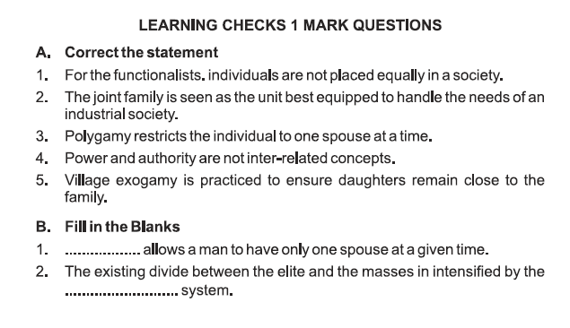
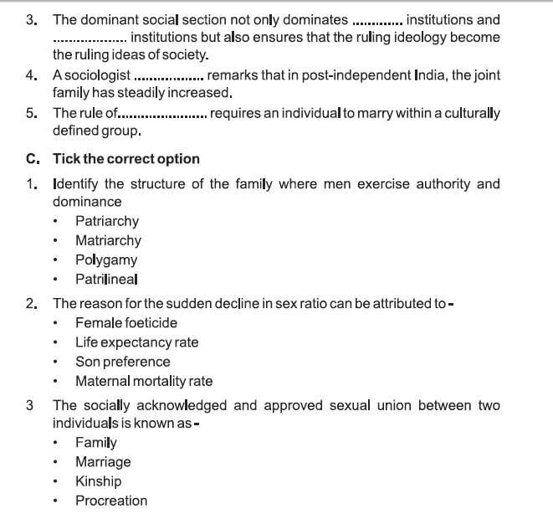
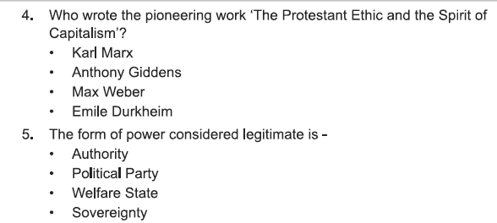
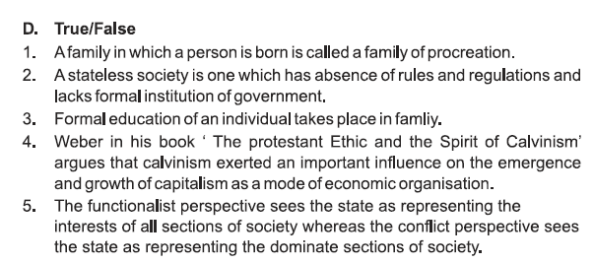

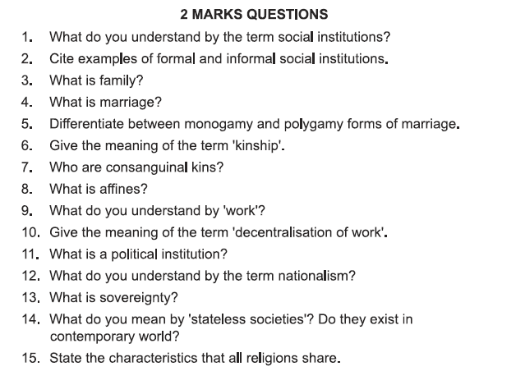
Answers:
Question 1: How joint family is different from nuclear family?
Answer: In joint family, husband, wife, children and close relations live together and contribute to family income as per their capabilities whereas nuclear family is basically a small family in which husband, wife and their unmarried children live.
Question 2: What is family?
Answer: A family is a group of persons directly linked by kin connections, the adult members of which assume responsibility of caring for children.
Question 3: State characteristics of family.
Answer. The characteristics of family are as follows:
- Universality
- Form of marriage
- System of nomenclature
- Limited size
- Economic provision
- Nuclear position in all social structure
- Responsibility of the members
- Social regulation
- Emotional basis
- Formative influence
Question 4: State the functions of a family.
Answer. Functions of a family include:
- Reproductive function
- Maintenance of family members
- Social placement of individuals
- Socialization of the young
- Social control
- Economic functions
- Educational functions
- Affective functions
- Religious functions
- Recreational functions
- Protective functions.
Question 5: State types of family.
Answer. Types of family include:
- Nuclear family
- Joint family
- Extended family ‘
- Matrilineal family (mother is decision maker).
- Patrilineal family (father is head of the family).
- Polygynous family (one husband, many wives).
- Polyandrous family (wife keeps many husbands at a time).
Question 6: Note what are the marriage rules that are followed in your society. Compare your observations with those made by other students in the class. Discuss.

Answer: In Indian society marriage has been regulated by certain norms. It is an institution for man and woman to enter family life. In our society marriage is not simply a contract instead it is a comprehensive relationship. It includes emotional involvement, loyalty, commitment for each other, economic attachment and responsibility. It is a stable relationship in which man and woman are socially committed to have children and the right to have children implying the rights to sexual relations.
- In our society, a marriage consists of a husband and wife i.e. monogamy. Individuals are allowed to marry again after the death of his/her spouse or after legal divorce.
In Indian society marriage is allowed between the two particular individuals of opposite sex. There are certain restrictions on choosing the life partner in traditional conservative families related to caste and religion.
In Indian society arranged marriages are preferred. Although many revolutionary changes have emerged in our society due to urbanization, industrialization, education among women, social reforms, globalization and various legal modifications e.g. women empowerment and property rights still traditional ideas around marriage continue.
- The young generation finds it uncomfortable in marrying someone whom they have never seen or met before, whose habits, values, attitudes, beliefs they don’t know. Youth find it very stressful. Nowadays nuclear families have replaced joint families and the social support of parents is also not available. So, this is a transitional period in Indian society as far institution of marriage is concerned.
Question 7: Find out how membership, residence pattern and even the mode of interaction changes in the family with broader economic, political and cultural changes-for instance migration.

Answer: Social relations are the base of group structure. Modern society is changing rapidly and so is the structure and composition. Change is a universal and continuous process. Due to industrialization, urbanization, globalization, information and technology, easy availability of electric and electronic gadgets and means of commutation has been a tremendous influence on our communication and social interaction. Now modern society is not significantly relationship oriented instead now it is time focused society. Therefore, with broader economic, political and cultural changes migration within the country as well as outside the country is a common phenomenon and due to low-cost calls, skype, WhatsApp and other sources the mode of social interaction has changed.

Question 8: What is marriage?
Marriage can be defined as a socially acknowledged and approved sexual union between two adult individuals. When two people marry they become kin to one another. The marriage bond however, also connects together to wider range of people.
Question 9: State a few objectives of marriage.
Answer. Objectives of marriage are:
- Fulfilment of biological needs of procreation and sexual satisfaction.
- Fulfilment of economic needs.
- Legitimization of children.
- Two families enter into kinship bonds and a complex web of social relationship develops.
Question 10: State any two functions of marriage.
Answer:
- Marriage sustains society by developing kinship bonds.
- Marriage facilitates and strengthens social status.
Question 11: What is exogamy?
Answer. It refers to the norms of avoidance in marital relationship. Marriage is not allowed among same ‘gotra’ and blood relations, according to exogamy.
Question 12: What is kinship?
Answer. Kinship toes are connections between individuals, established either though marriage or through line of descent that connect blood relatives (mothers, fathers, siblings, offspring, etc)
Kinship system determines:
- Rules of social behaviour
- Provides social help and security
- Maintenance of socio-cultural relationship
- Regulates social behaviour
Additional Question Answers:
Meaning of the term Social Institution:
A social institution in the broadest sense is something that works according to the rules established or at least acknowledged by law or by custom. And whose regular continuous operation cannot be understood without taking those rules into account. Institutions impose constraint on individuals. They also provide them with opportunities.
Example of Formal and Informal Social Institutions
Institutions such as family and religion are examples of informal social institutions while law and formal education are examples of formal social institutions.
Meaning of Consanguineal – related by blood and Affine- related through marriage
WORK AND ECONOMIC LIFE
Question 13: Define work
Answer: Work (whether paid or unpaid) is the carrying out of tasks requiring the expenditure of mental and physical effort, which has as its objective the production of goods and services that cater to human needs.
Question 14: What do you mean by wage?
Answer: It refers to a fixed amount which is essential part of contract between the employer and employees and it is regulated by law.
Question 15: What is contract?
Answer: Contract is an agreement between two individuals or groups or individuals and a group under some terms and conditions to attain certain goals in a fixed period of time.
Question 16: What are Economic Institutions?
Answer: Economic Institution refers to a coordinated activities of individuals or groups with regard to production, distribution and consumption of products and services in the society.
Question 17: Write an essay on ‘work’. Focus on both the range of occupations, which exist and how they change.
Answer: Work is not only for livelihood but also for satisfaction. It involves carrying out tasks which require physical and mental activities.
Work refers to paid employment. It can be termed as the physical or mental efforts of the individual. It may be paid or unpaid, it is performed as services to cater the human needs. The work may be performed in direct exchange of goods of services.
The economic activities other than social and political activities, form an important part of human social life. Economic Institutions coordinate activities of individuals with regard to production, distribution and consumption of goods and services in the society.
Work involves many dimensions such as:
- Contract: An agreement between two or more people having same rules and conditions to attain specific goals in a specified period of time.
- Division of Labour: Refers to a system of distribution of work among the people. based on their skills and competence. Division of labour is directly connected with density of population. It makes members of society interdependent. The modern society and its economy are technology based that requires specialization.
- The wages: In present industrial economy wages follow certain rules such as:
  - Wage is fixed and essential part of contract.
  - It is impersonal and based on formal relations.
  - Wages are binding on both parties, the employee and the employer.
  - In certain economic systems, Trade Union, or Labour Unions protect the wage interests of the workers.
There are various economic systems in which the work gets manifestation:
    - Primitive Economic System:
Work and wage has no specific exchange policy. Essentially private but
community based involving economic, religious and magical activities.

(b) Agrarian Economy:
This was second stage of economic system which ensured continuous food supply for workers.
The occupation became caste based and barter system and jajmani system prevailed.
(c) Industrial Economy:
This is present day economic system that began with industrialization in England in 18th century. Capitalism and socialism emerged as two basic systems of industrialized society. This society is based on tools and machines for the production. These economic systems regulate the work with a fixed currency. Division of labour, factory system, interdependence for production and specialization of task are the main features of present-day economy.
Work can be categorised as:
- Formal sector: Here the idea of paid employment functions.
- Informal sector: It refers to an economy which, involves the direct exchange of goods or services. Informal economy refers to transaction outside the sphere of regular employment.
- Service sector: In service sector most of the work is being provided to people in communication, health, education, hotel, aviation, I.T, transportations, computer etc.
- Public sector: Employment generated by the government is called public sector work e.g. Railways, Heavy Industries. They are part of public sector. India being a welfare state many areas like transport is managed by the government only.
- Private sector: The work which is regulated by private owners. This is basically profit making business field e.g TCS, Infosys etc.
- PPP: It is a new concept in which public sector i.e. government and private sector coordinate each other for the development of economy.
POLITICAL INSTITUTIONS
Question 18: What is state?
Answer: State is an association or a group of people having a definite territory, own population, government and sovereignty. Its main institutions are law and the right to administer, through which it can maintain control in a definite territory.
Question 19. What is a welfare state?
Answer: It refers to a system in which the government ensures responsibilities for the welfare of its citizens like food, health care, education, employment and housing etc.
Question 20: Explain concepts of power and authority.
Answer: Central to the study of political institutions are the concepts of power and authority. Political institutions are concerned with the distribution of power in society.
Question 21: What are Political Institutions?
Answer:
- Political Institutions are institutions of formal social control. They are mechanism or agencies related to the exercise of legitimate power for maintaining order within a society.
- A sociological study of politics seeks to understand how political elements like leadership, power and authority, voting behaviour etc. are influenced by social factors like class, caste, race, religion etc.
Question 22: What is power?
Answer:
- According to Weber, “Power is the ability of an individual or a number of persons to exercise their will even against the resistance of others.”
- It is the ability to control others and to fulfil one’s interest, despite resistance. There is always an element of coercion present in the exercise of power.
- Unqualified power by itself is unstable. It can’t last for too long.
Question 23: Explain concept of authority.
Answer:
- Authority is legitimate power. It is the exercise of will which is voluntarily accepted.
- As legitimate power, authority is socially recognized and justified. It is, therefore, based on consent.
There are three main types of authorities or three main sources of legitimization of power.
1. Traditional authority: It is accepted by people out of habit. People accept the power of someone simply because it has been done so in the past. Traditional authority, therefore, rests on customs. It is not based on written laws. This authority is irrational and personal. For example, the authority of a king in a monarchy.
2. Charisma and authority: Here people accept the authority of a person due to extraordinary qualities of that individual. For example, Gandhi ji. This authority is neither customary nor is it based on written laws. It is both irrational and personal.
3. Legal rational authority: Here the power and privileges are clearly defined and limited by written rules or law.
The actual power lies not in the person who wields it, but in the position that he/ she occupies. Eg. the authority of the Prime Minister in democracy.
Question 24: Explain concepts of community, nation and state and differentiate them.
Answer: A community refers to a group of people whose members are connected to each other by consciously recognized commonalities which, may be based on language, religion, culture and so on.
Nation: A nation is a territorial community psychologically bound together by common ties of kinship, religion, language, history, customs or traditions. A nation has aspirations for political autonomy or political organization. It is not sovereign.
The desire for political unity of a nation expresses itself as the aspiration to form a state.
State: It is a community of persons, settled in a definite territory, having an organized government, and enjoying absolute independence from external control. It has the following elements:
Population: There can be no state without people as state is an association of people. Exact number of people essential to form a state cannot be fixed. However, just a few families can’t constitute a state. Population should be more or less numerous.
Territory: A group of people must occupy a clearly defined territory in order to constitute a state. A group of nomads cannot constitute a state. Territory of a state includes a clearly demarcated piece of land, territorial waters, and even the entire air above the territory of the state. This territory is under the supreme control of the state.
Government: It is the machinery or agency through which the state functions and exercises its will. It includes selected people to enact laws, implement them and enforce justice. It maintains official relations with other states. All members of the state are not part of the government. It includes only those officials, and departments who are elected, appointed or employed to determine and carry out the regulations of the state.
Sovereign: It is the absolute power of the state. State has full and independent control over its territory and population. It is independent of any external control.
Nation-state: Nation states are those states in which the great mass of population are citizens who regard themselves as a part of a single nation.
Differences between community, nation and state:
- Community: No political aspirations to form a state.
- Nation: A community with political aspirations not yet a state, not sovereign.
- State: A state is a politically organized community, sovereign and internationally recognized.
Question 25: Discuss the kind of rights that exist in your society. How do they affect your life?
Answer: India a largest democracy in the world and being a welfare state has given above rights to her citizens mentioned below.
Kinds of Rights
- Civil rights: Right to information, right to education, freedom of speech, freedom to follow religion, food security are several civil rights which all the people of a democratic India enjoy.
- Social rights: All Indian citizens have right to enjoy a minimum standard of welfare and security such as health benefits. Minimum level of wages, old age benefits or employment allowance particularly for BPL people.
- Political rights: Right to vote and freedom of expression are political rights.
- Welfare rights: Social security in developed western countries.
These rights have changed the structure, composition and functioning of Indian society. Freedom, equality, liberty of expression, faith and religion have changed the composition of social network and people find themselves confident, politically aware and mature. The social rights are giving poor people an opportunity of education, keeping good health and minimum wages which prevent people from exploitation. Right to franchise makes the people real king maker. Because of this right Indians can choose their government.
RELIGION AS A SOCIAL INSTITUTION
Question 26: Explain religion as a social institution.
Answer: Religion is a unified system of beliefs and practices related to sacred things, creating into a single moral community of all those who adhere to those beliefs and practices.
- Religion believes in supernatural power.
- Religion follows specific rituals.
- Different religions have their own identity and symbols.
Religion plays an important role in social structure by providing social control.
Question 27: How does sociology study religion?
Answer: According to Emile Durkheim, “Religion is a unified system of beliefs and practices relative to sacred things, creating into a simple moral community all those who adhere to those beliefs and practices.”
- Sociologists study religion as the belief in spiritual beings.
- Religion is a mode of action as well as a system of beliefs and a sociological phenomenon as well as personal experience.
- Religion rests upon beliefs in supernatural which embraces animism.
- From sociological perspective religion performs many functions for the society. It is a form of social control.
- Religion exists in all known societies although religious beliefs and practices vary from culture to culture.
- Religion is only a personal phenomenon, but also has a public aspect which has an important influence upon the social institution.
- Religion is the collection of customs and rituals. Because of religion people respect the customs and norms which maintains the social network.
- Religion encourages people to develop a complex, balanced, integrated, healthy and happy personality and get involved in social welfare activities. It helps people in maintaining internal force.
Sociologists study the public form of religion because it is quite important from social perspective which takes care of society and social institution.
EDUCATION AS A SOCIAL INSTITUTION
Question 28: Write an essay on school as a social institution. Draw from both your reading as well as your personal observations.
Answer: School is a social institution which provides formal learning with an objective of an all-round development of personality.
School through classroom teaching and curricular and co-curricular activities makes children grow, fully functioning, creative self-actualizing, good human beings. Schools facilitate physical, mental, emotional, spiritual and social development among children.
Schools provide an environment through which social norms are transmitted to children.

Question 29: What is education? Discuss its importance and various forms.
Answer: Education is an effort of the senior members of the society to transfer their knowledge, skills and values to the younger members of society. It is the process of giving intellectual, moral, physical and social instructions to a child for his all-round development.

Importance of education:
- It socializes the child to play adult roles in society. A child through education learns the basic rules, regulations, norms and values of society.
- It helps in maintaining and perpetuating the society and its culture.
- It also helps in promoting change by instilling new ideas and values.
- It provides the necessary knowledge and skills to an individual to be a productive member of society.
1.Formal and Informal Education
Formal Education: It is in the form of systematic, planned and guided instruction. It is highly institutionalized and organized. It has the following characteristics:
- There is a definite and well-defined content and curriculum of education.
- There are definite rules and regulations regarding admission, evaluation etc.
- Instruction is provided by specially qualified teachers.
- It is limited to a definite period or stage, For example, college education. Informal Education
Informal education is spontaneous and largely unplanned.
- There is no fixed curriculum and there are no specialized agencies like schools or colleges imparting such education.
- Informal education involves learning of values, norms, morals, family rituals, ceremonies etc. through participation at everyday activities.
- It goes on from birth to death. There is no particular stage or age for this.
2. Education in Primitive and Modern societies:
In primitive societies:
- The content of education was mainly related to religion, philosophy, metaphysics and scriptural subjects.
- There was no need for formal schooling and informal education played a greater role.
Modern industrial societies:
- Course content of education is rationalistic and secular. As the modem society relies on an extremely elaborate division of labour it stresses on teaching subjects like sciences, mathematics, languages etc.
- Being change oriented it lays emphasis on instilling principles of democracy, secularism, equality and a scientific world view.
- Formal education plays a greater role in modern societies rather than it did in primitive societies.

